Assignment 5 in gem5.

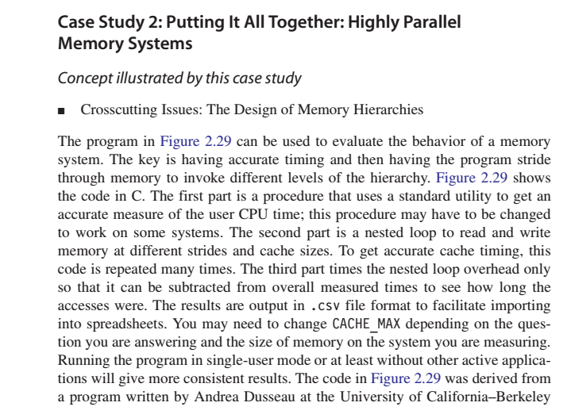

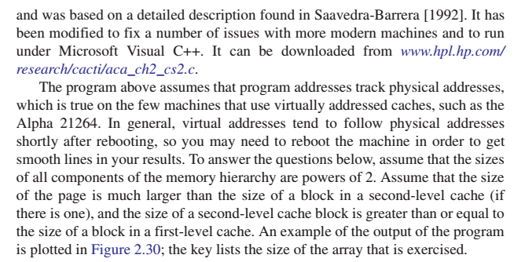

**program for evaluating memory system.**

#include "stdafx.h"

#include <stdio.h>

#include <time.h>

#define ARRAY_MIN (1024) /* 1/4 smallest cache */

#define ARRAY_MAX (4096*4096) /* 1/4 largest cache */

int x[ARRAY_MAX]; /* array going to stride through */

double get_seconds() { /* routine to read time in seconds */

__time64_t ltime;

_time64( &ltime );

return (double) ltime;

}

int label(int i) {/* generate text labels */

if (i<1e3) printf("%1dB,",i);

else if (i<1e6) printf("%1dK,",i/1024);

else if (i<1e9) printf("%1dM,",i/1048576);

else printf("%1dG,",i/1073741824);

return 0;

}

int _tmain(int argc, _TCHAR* argv[]) {

int register nextstep, i, index, stride;

int csize;

double steps, tsteps;

double loadtime, lastsec, sec0, sec1, sec; /* timing variables */

/* Initialize output */

printf(" ,");

for (stride=1; stride <= ARRAY_MAX/2; stride=stride*2)

label(stride*sizeof(int));

printf("\n");

/* Main loop for each configuration */

for (csize=ARRAY_MIN; csize <= ARRAY_MAX; csize=csize*2) {

label(csize*sizeof(int)); /* print cache size this loop */

for (stride=1; stride <= csize/2; stride=stride*2) {

/* Lay out path of memory references in array */

for (index=0; index < csize; index=index+stride)

x[index] = index + stride; /* pointer to next */

x[index-stride] = 0; /* loop back to beginning */

/* Wait for timer to roll over */

lastsec = get_seconds();

sec0 = get_seconds(); while (sec0 == lastsec);

/* Walk through path in array for twenty seconds */

/* This gives 5% accuracy with second resolution */

steps = 0.0; /* number of steps taken */

nextstep = 0; /* start at beginning of path */

sec0 = get_seconds(); /* start timer */

{ /* repeat until collect 20 seconds */

(i=stride;i!=0;i=i-1) { /* keep samples same */

nextstep = 0;

do nextstep = x[nextstep]; /* dependency */

while (nextstep != 0);

}

steps = steps + 1.0; /* count loop iterations */

sec1 = get_seconds(); /* end timer */

} while ((sec1 - sec0) < 20.0); /* collect 20 seconds */

sec = sec1 - sec0;

/* Repeat empty loop to loop subtract overhead */

tsteps = 0.0; /* used to match no. while iterations */

sec0 = get_seconds(); /* start timer */

{ /* repeat until same no. iterations as above */

(i=stride;i!=0;i=i-1) { /* keep samples same */

index = 0;

do index = index + stride;

while (index < csize);

}

tsteps = tsteps + 1.0;

sec1 = get_seconds(); /* - overhead */

} while (tsteps<steps); /* until = no. iterations */

sec = sec - (sec1 - sec0);

loadtime = (sec*1e9)/(steps*csize);

/* write out results in .csv format for Excel */

printf("%4.1f,", (loadtime<0.1) ? 0.1 : loadtime);

}; /* end of inner for loop */

printf("\n");

}; /* end of outer for loop */

return 0;

}

Attempt Exercise 2.4, page No: 135